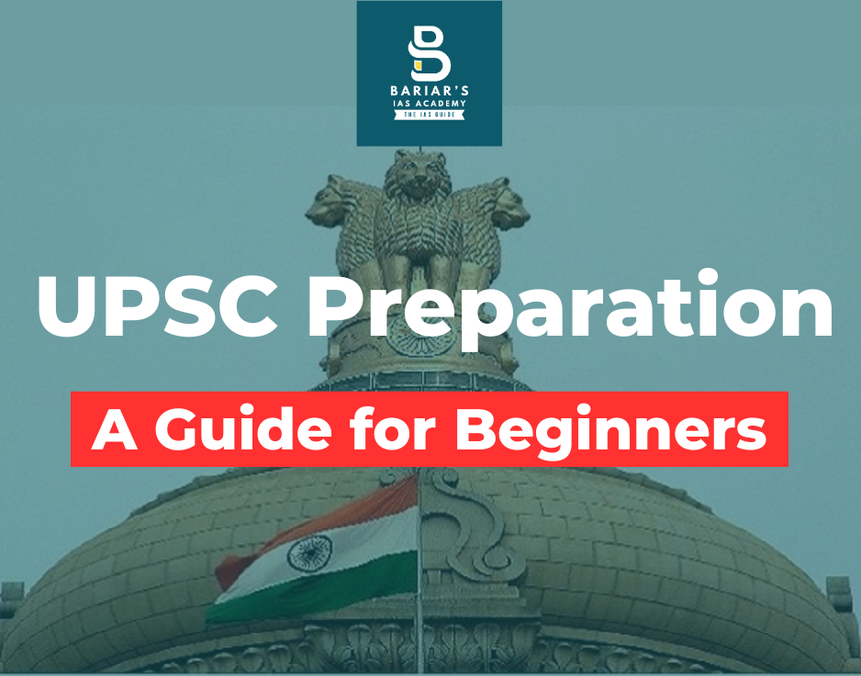

UPSC Preparation – A Guide for Beginners
Understanding the Examination
The UPSC Civil Services Examination is conducted in three stages—Preliminary Examination, Main Examination, and the Personality Test. Although these stages are distinct in format, preparation must be integrated from the very beginning. Prelims Stage tests conceptual clarity and factual precision, while Mains Exam evaluates analytical ability and depth of understanding. The Interview assesses personality traits such as balance, awareness, and decision-making capacity. A beginner must recognise that success lies in preparing for all three stages simultaneously rather than in isolation.
Start with the Syllabus and PYQs
The syllabus is the foundational document of UPSC preparation. Before opening any book, a serious aspirant should carefully read and understand the detailed syllabus of both Prelims and Mains. Equally important is the analysis of Previous Year Questions (PYQs). PYQs reveal recurring themes, the depth of questions, and the evolving nature of the examination. They prevent over-preparation and help aspirants focus on relevant areas.
Building a Strong Foundation
Preparation should begin with NCERT textbooks to build conceptual clarity, followed by one standard reference source per subject. Avoid the common mistake of accumulating multiple books. UPSC rewards revision and clarity, not excessive material. Alongside static subjects, consistent reading of current affairs is essential, as contemporary issues are increasingly linked with core concepts.
Discipline, Consistency and Mindset
A structured daily routine with dedicated time for study, revision, and gradual answer writing practice is crucial. While coaching can provide guidance and structure, self-study remains indispensable. Ultimately, UPSC preparation is a test of consistency, patience, and emotional resilience. A focused beginning, guided by strategy rather than impulse, significantly increases the probability of long-term success.

